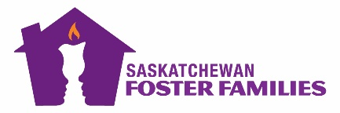
FASD Virtual Training Registration Form

The Saskatchewan Foster Families Association provides assistance to the Ministry of Social Services to ensure all foster parents across Saskatchewan have completed their provincially mandated training. FASD Foster Parent Training, deals with children that have Fetal Alcohol Spectrum Disorder and helps families understand the supports and strategies they can use in their homes.

Training Schedule: Select One date below

We would ask that you login into the classroom by no later than 6:20PM to ensure a stable and working connection.

Name(s): Click or tap here to enter text.
Address: Click or tap here to enter text. City/Town: Click or tap here to enter text.
Postal Code: Click or tap here to enter text. Mobile Phone:Click or tap here to enter text.
Email Address: Click or tap here to enter text. Ministry Worker: Click or tap here to enter text.

Registration forms should be completed and sent by email to: training@sffa.sk.ca or by fax: 306.975.1581

☐ March 27th, 2023; 630PM-930PM **Registration must be received no later than March 24th

☐ May 24th, 2023; 630PM-930PM **Registration must be received no later than May 23rd

If you have questions regarding the training or your registration, please email:
training@sffa.sk.ca or call the SFFA Recruitment and Training Coordinator at 306.975.1528

